Sticky Notes Applications
Class Diagram :

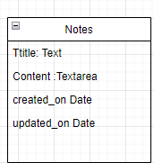

UserCase Diagram
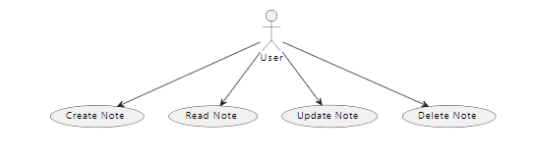

Sequence Diagram

